**Lab 3: Entity Relationship Diagram**

**Objectives:**

The primary objective of this task is to import the Northwind database into MySQL Workbench and perform an in-depth analysis of its structure. This involves downloading the northwind-db.sql file from the provided classroom link and importing it into a newly created database named northwind in MySQL Workbench. Once imported, the total row count for each table needs to be verified to ensure the integrity of the data. Additionally, the attributes and constraints of each table must be examined to understand the database schema. The final step involves creating a comprehensive Entity Relationship Diagram (ERD) using draw.io, highlighting the relationships between different entities with appropriate shapes and colors to distinguish between entities and their attributes. This diagram will serve as a visual representation of the database structure, aiding in better comprehension and communication of the database design.

1. **Data Import:**
2. **Download northwind-db.sql from classroom link**
3. **Open MySQL Workbench and Login using root or <name>**
4. **Create database <name>northwind**

**Query:**

create database sulav_northwind;

**Output:**

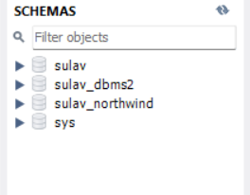

1. **Import downloaded database in <name>northwind**

**Output:**

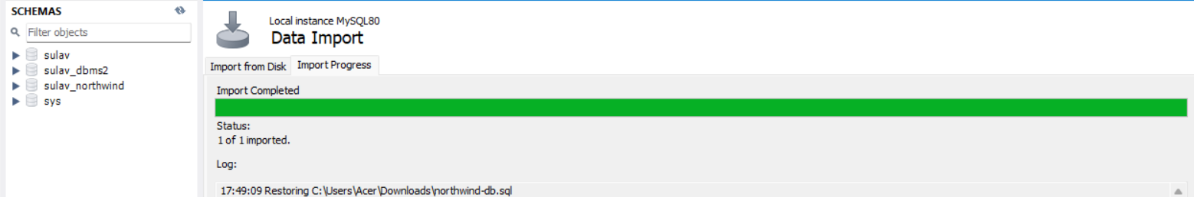

1. **Check Total Row Count in each table**
2. **Categories**

**Query:**

USE sulav_northwind;

select count(*) from categories;

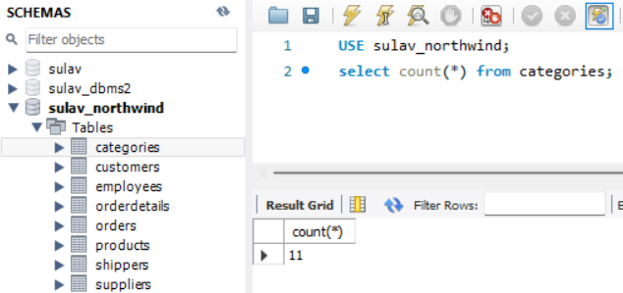**Output:**

1. **Customers:**

**Query:**

select count(*) from customers;

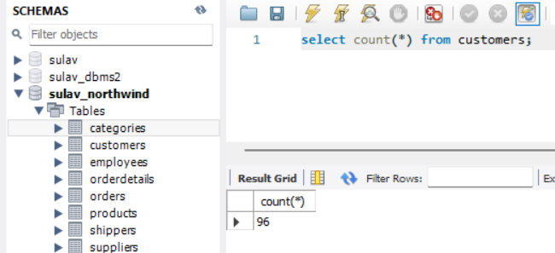**Output:**

1. **Employees:**

**Query:**

select count(*) from employees;

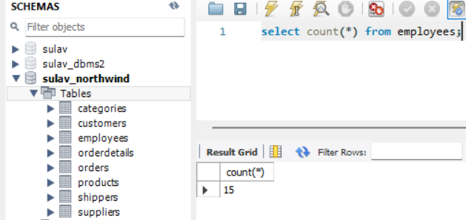**Output:**

1. **Order details:**

**Query:**

select count(*) from orderdetails;

**Output:**

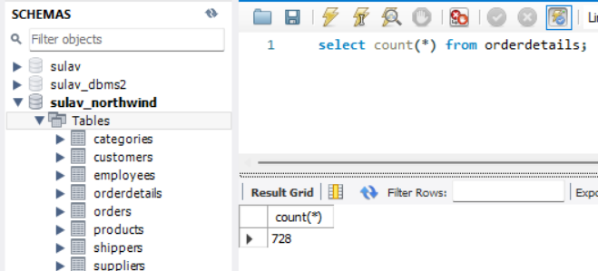

1. **Orders:**

**Query:**

select count(*) from orders;

**Output:**

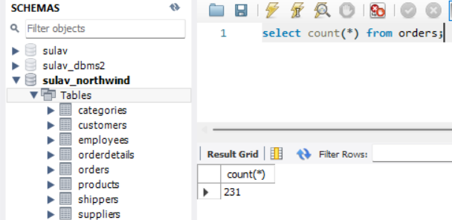

1. **Products**

**Query:**

select count(*) from products;

**Output:**

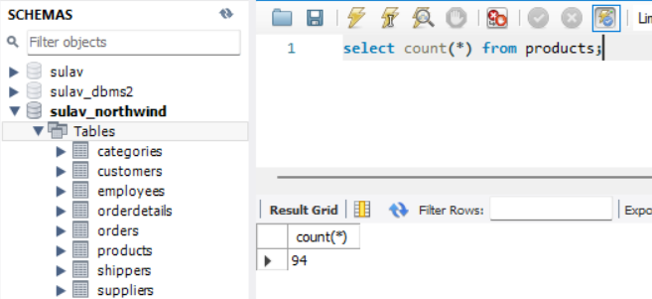

1. **Shippers**

**Query:**

select count(*) from shippers;

**Output:**

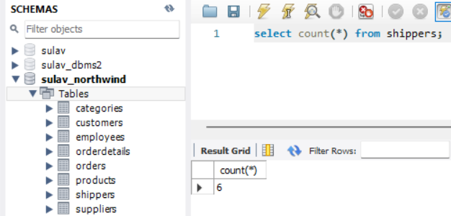

1. **Suppliers**

**Query:**

select count(*) from suppliers;

**Output:**

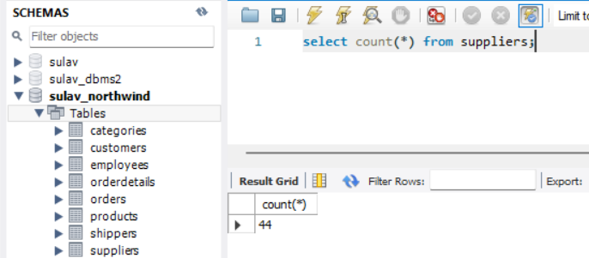

1. **Check attributes and constraints in each table**
2. **Categories:**

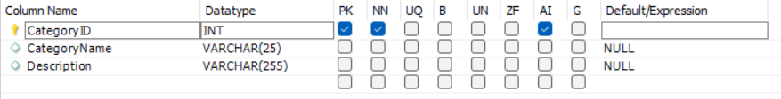

1. **Customers:**

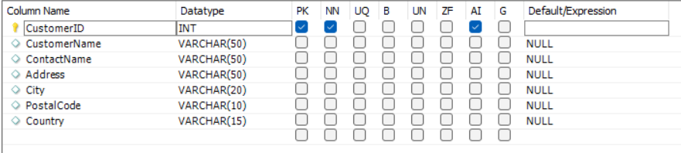

1. **Employees:**

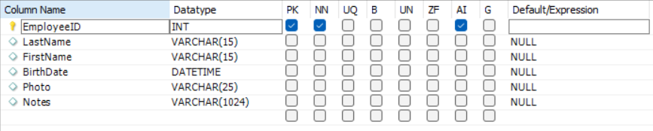

1. **Order Details:**

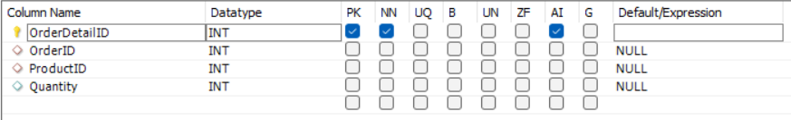

1. **Orders:**

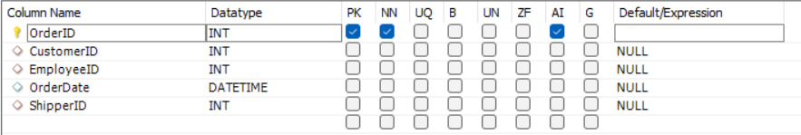

1. **Products:**

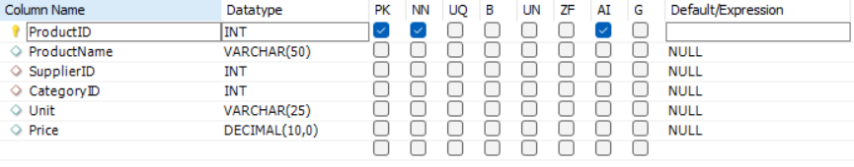

1. **Shippers:**

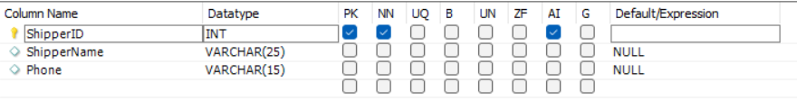

1. **Suppliers:**

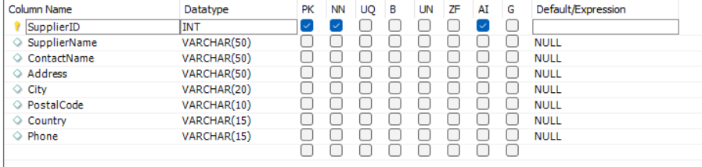

1. **Draw Entity Relationship Diagram**
   * 1. **Open any internet browser**
     2. **Open** [**https://draw.io**](https://draw.io)
     3. **Select appropriate storage for your draw.io files (Prefer: Google Drive)**
2. **Authorize the access**
   * 1. **Draw ER diagram of <name>northwind database**
3. **Use appropriate shapes of ER diagram**

**ii. Use various colors to different Entity and attributes.**

**Conclusion:**

Successfully importing the Northwind database into MySQL Workbench and analyzing its structure provides valuable insights into the database schema and its constraints. Verifying the row counts ensures data integrity, while examining the attributes and constraints reveals the relationships between different entities. Creating an ER diagram using draw.io further enhances understanding by visually representing these relationships. The use of various shapes and colors in the diagram aids in distinguishing between different entities and attributes, making the database design clearer and more accessible. This comprehensive approach ensures a thorough understanding of the Northwind database. Overall, the process strengthens database management skills and prepares for more complex database tasks in the future.